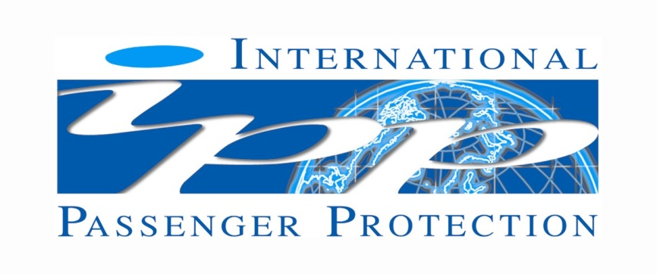

MAGIC MOMENTS FINANCIAL FAILURE HOLIDAY INSURANCE

In accordance with the UK Package Travel & Linked Travel Regulations 2018 all passengers booking with Andrew Holden t/a Magic Moments are fully protected for the initial deposit and subsequently the balance of all monies received by us, including repatriation costs and arrangements, arising from cancellation or curtailment of your travel arrangements due to the insolvency of Andrew Holden t/a Magic Moments

There is no requirement for Financial Protection of day trips or single elements, and none is provided.

Andrew Holden t/a Magic Moments has taken out an insurance provided by International Passenger Protection Ltd (IPP) with Liberty Mutual Insurance Europe SE (LMIE) trading as Liberty Specialty Markets, a member of the Liberty Mutual Insurance Group. LMIE's registered office: 5-7 rue Leon Laval, L-3372, Leudelange, Grand Duchy of Luxembourg, Registered Number B232280 (Registre de Commerce et des Sociétés). LMIE is a European public limited liability company and is supervised by the Commissariat aux Assurances and licensed by the Luxembourg Minister of Finance as an insurance and reinsurance company. This insurance is only valid for passengers who book and pay directly with/to Andrew Holden t/a Magic Moments

In the event of our insolvency please make contact as soon as practically possible giving full details of what has happened quoting the name of your Travel Operator:

IPP Claims at Sedgwick
Telephone: +44 (0)345 266 1872
Email: Insolvency-claims@ipplondon.co.uk
or online at http://www.ipplondon.co.uk/claims.asp

